Station 1: Read and answer the question on your packet!

Caring and Handling the New Baby Chicks
Once the chicks hatch, human instinct is to want to hold them right away! But newly hatched chicks should not be handled much, if at all. As babies, too much handling can stress the chicks out and cause them to get sick. It is also important to make sure hands are washed before and after handling baby chickens to ensure that harmful bacteria are not passed to chickens or humans.
After all the chicks hatch, they must stay in the incubator until their feathers are completely dry. Birds can then be moved to an environment that provides heat, food and clean water. The new environment, called a brooder, should be maintained at 95F for the first week. This can be accomplished by adding a heat lamp to the brooder. It is easy to tell if the temperature in the brooder is correct. If chicks are clustered under the heat source, it’s too cold for the chicks. If chicks are far away from the light, it is too hot in the brooder. But if the chicks are evenly spaced out throughout the brooder, you know you have achieved a comfortable temperature for the new babies!
The bottom of the cage should be lined with pine shavings (similar to wood chips) or shredded paper towels and newspaper. Do not use a slippery lining like magazine paper, because it can cause damage to the chicks’ developing legs. Chicks also need a constant supply of clean water. Use a shallow dish filled with water. Adding marbles or gravel to the water will prevent the chick from drowning (baby chicks drown easily!). Also make sure the chicken have a constant supply of food. For the first few weeks, they should eat chick starter food: feed mixed with nutrients, vitamins and medicine to keep the chicks growing and healthy. Don’t let the food run out!

Station 2: Look at the diagrams and answer the questions on your worksheet.

*Note: A commodity is useful agricultural product that can be sold.
A broiler is a chicken used for meat to eat.

Station 3: Use the information cards to answer the questions on your worksheet.

Types/Uses of Chickens:
Egg Layers: Chickens used to produce large amounts of eggs
Broilers: Chickens used for meat
Dual Purpose Chickens: Breeds that can be used as layers and broilers
Fancy: Breeds that have distinguishing features that stand out. Used for show and hobbies.

Station 4: Look at the diagram and fill in the missing information on your diagram. Then, answer the questions.

Station 5: Look at the diagram and answer the questions on your worksheet.

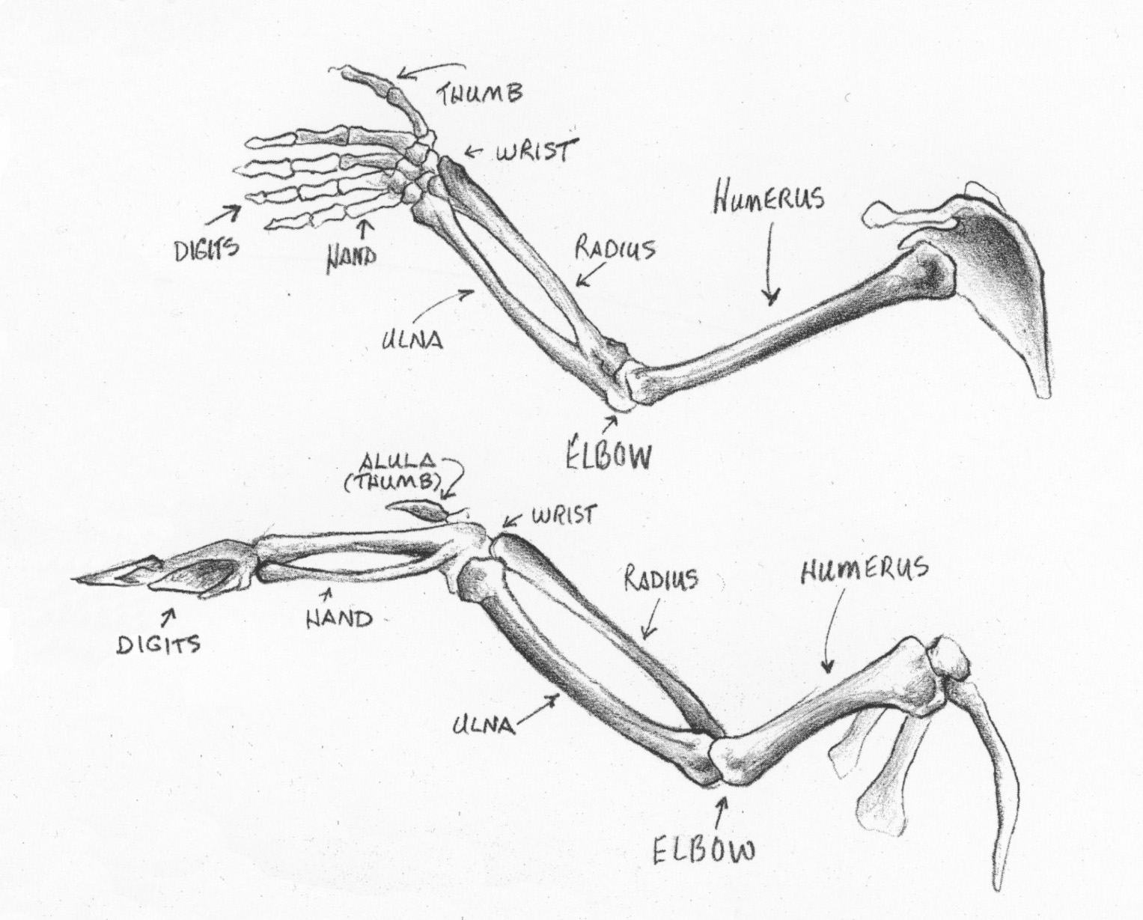

Picture from: http://blogs.hightechhigh.org/rtinoco2014/

Station 6: Color the diagram on your paper according to the directions below.

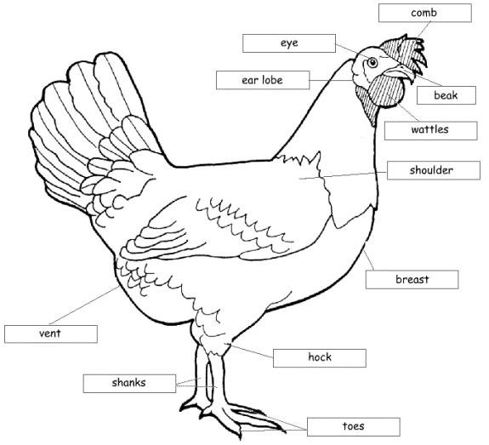

Photo from: http://ecap.crc.illinois.edu/eecearchive/books/projcat3/section3/17.gif.

